Simple solution to hard starting on early XM models

Translator’s note:
This article was copied from a Japanese web site with the permission of the author, Katsuyuki Wakishima. The author, nor the translator, accepts any responsibility for damage due to modifications to the vehicle described here.

Jan Burgel

XM Diary

Solving hot starting problems
1999.12.30 , 2000.1.3
Had great difficulty restarting the XM within short intervals after having driven it some time. Although bothersome, it did not impede driving the car, so naturally it was left as it was. Until an XM expert heard from a certain lady about a way to improve things and I put this into practice.
The cause (thought to be) leaning of the fuel mixture when restarting at a high coolant temperature. Or maybe ignition timing?
According to the manual the injectors deliver fuel 3 times per 1 engine revolution when cold, under normal conditions once. During cold start coolant temperature is thought to be the main criterion. The solution is to create the same environment when restarting as with a cold engine. In addition to the amount of injected fuel, the temperature of the air inhaled seems to be a factor. The actual solution is to install an additional relay and a fixed resistor to trick the ECU with a fake low coolant temperature during cranking.
To activate the additional relay we use the starter motor relay indicated in photo #1 by the red arrow.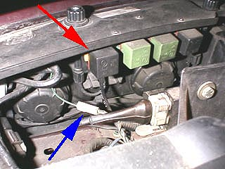
First I switched the additional relay in parallel to the starter motor relay, but I found out that when the ignition is ON voltage is constantly supplied here. For about 4 days I drove around with the ECU thinking the engine was always cold! Except for the idling speed being a little higher nothing unusual had happened . . .
Learning from this I switched the feed for the additional relay to the drive of the starter motor. I was worried about a voltage drop taking the power from here, but a simulation using a 3A battery charger did not reveal any problems.
Wiring:
Connect wires to terminal 3 and 4 of the starter motor relay. Hook up the unused single connector of the cruise control (blue arrow in photo) to terminal 4.
The additional relay I used, indicated by the red arrow in photo #2, is the airconditioner compressor cut off relay on injection models.
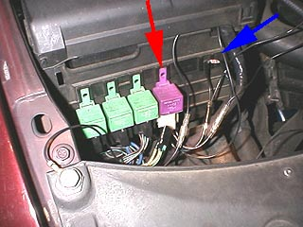
This relay is to cut off the compressor when engine is under heavy load. However on Japanese models (?) this relay has been disabled - the feed has been cut. This relay is the normally closed type (voltage OFF), so suitable. Cut the 3 wires attached to the relay and connect the wire from terminal 1 to the wire coming from the starter motor relay.
Connecting terminal 2 to mass (earth) should activate the relay when spinning the starter.
Incidentally, failing to connect the severed yellow wire from the cut off relay to a live source will disable the airconditioner. Next hook up 2 wires to terminals 3 and 4, to the resistor (blue arrow) and in the direction of the coolant temperature sensor.
Sever the wire to the coolant temperature sensor hook up the leads coming from the additional relay, and you're done.
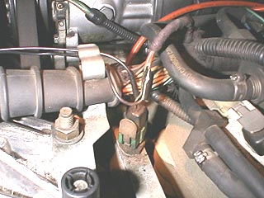
The resistor used is rated at about 1.5 K Ohm.
According to the manual the coolant sensor resistance at 10 degrees is about 4 K Ohm, at 20 degrees 2.5 K Ohm, at 55 degrees 680 ohm and at 90 degrees 221 Ohm. There seems to be room for adjusting the value of the resistor.
Where starting was a pain before it is now instantaneous. Thanks for the advice.
Katsuyuki Wakishima

